**SOP to change Source and Destination Mail ID’s**

1. Go to SES in AWS. Click on “Create identity”.
2. 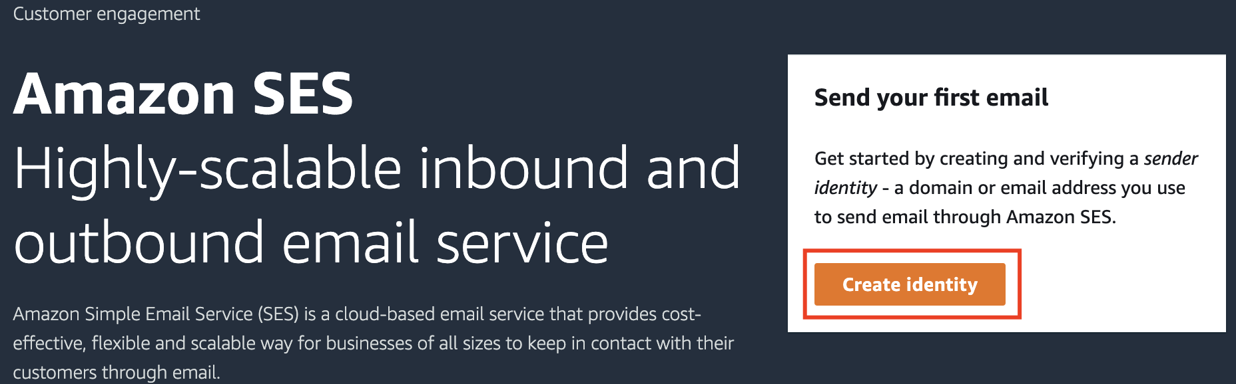
3. Select Email address and pass in the mail address you want to add. Click on “Create identity”.
4. 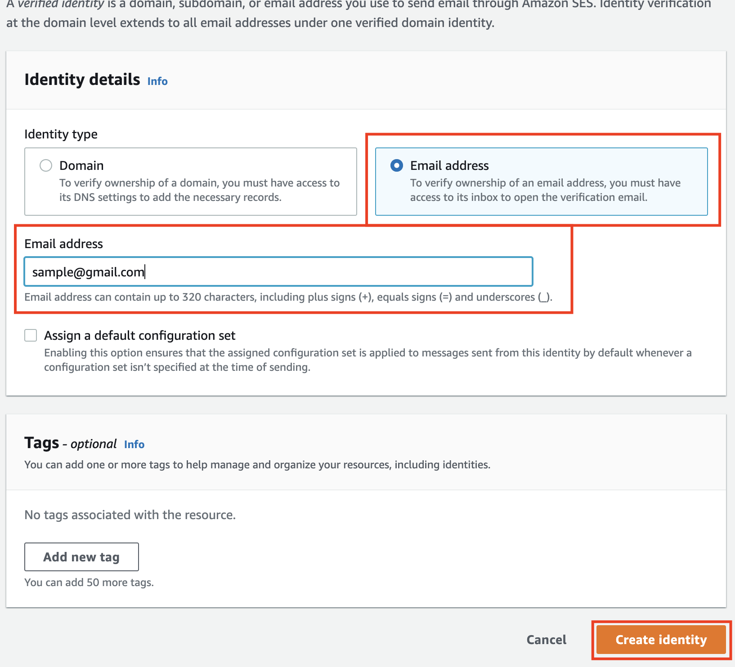
5. To verify the mail address go to inbox, AWS SES would have sent a confirmation email with a URL, click on the URL to get as verified in the SES.
6. Once you verify the mail you can see as Verified in the SES.
7. 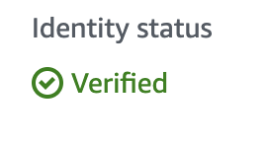
8. Now jump on to the Lambda, Select the lambda function named “Feedback-E-mail-SES”.
9. 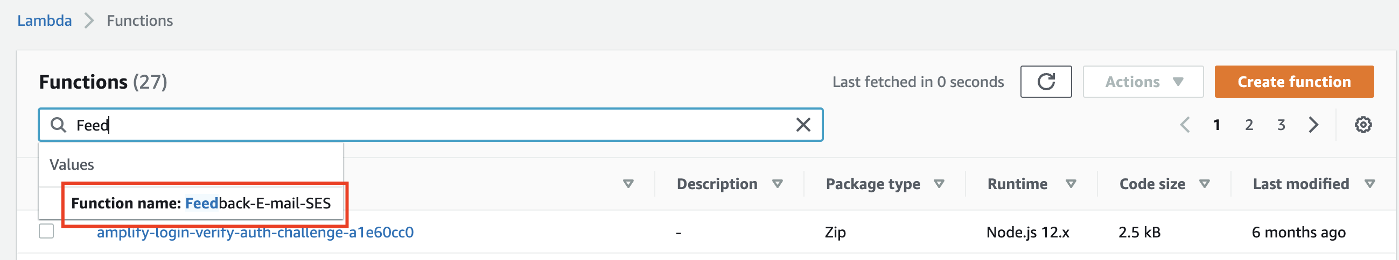
10. Scroll down and go to “code source”
11. 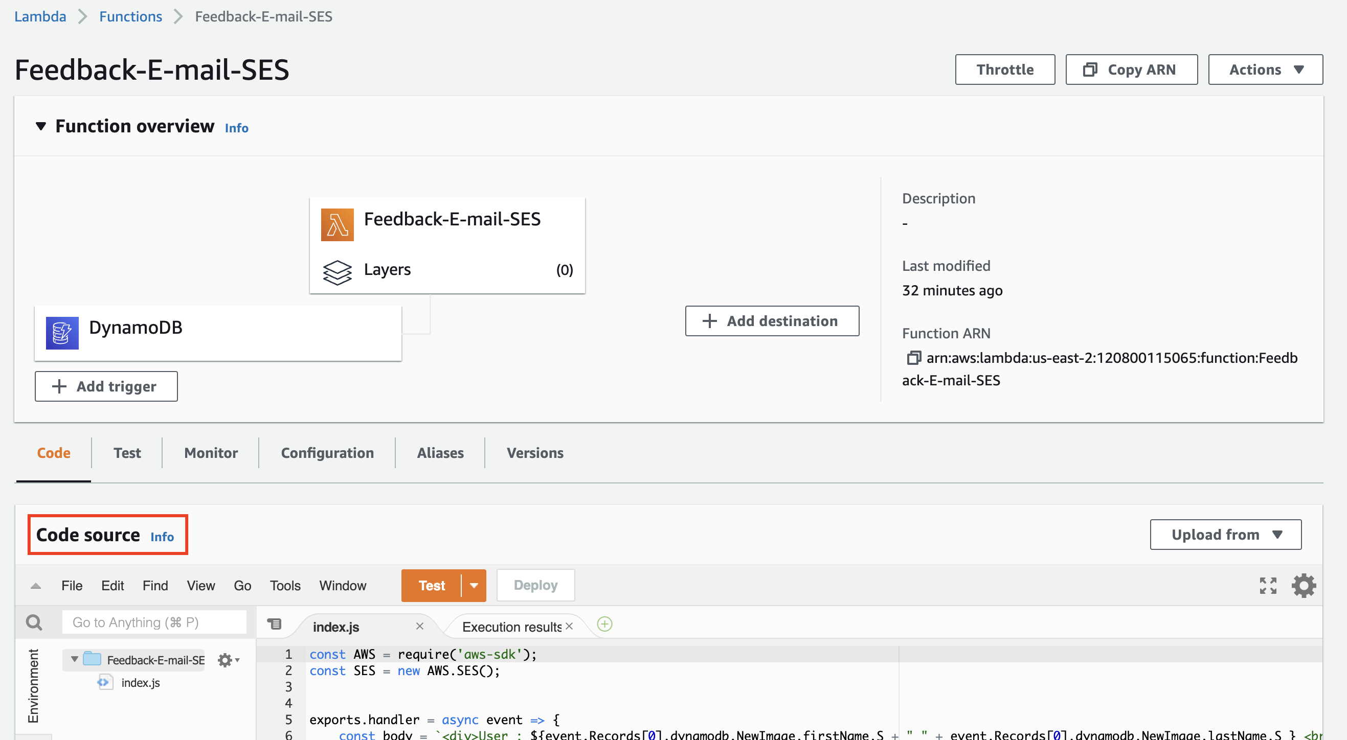
12. Change the “Source” , “ToAddresses” and click on deploy as shown in below snap.
13. 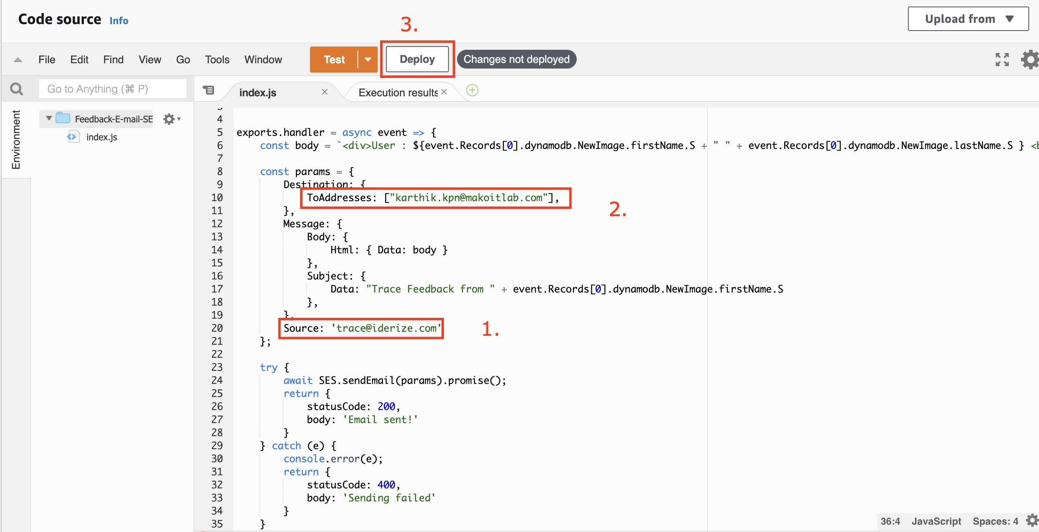
14. Note : Make sure to create and verify the mail addresses before you change in the code.
15. Once deployed you are good to go!!!